Assignment 5

Q1. WAJP to find the area of a triangle

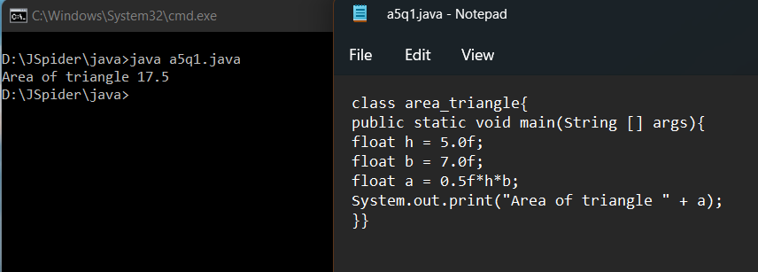

Q2. WAJP to find the area of circle

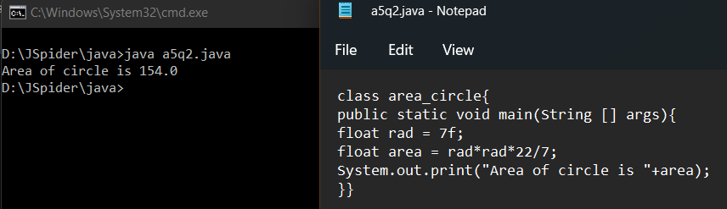

Q3. WAJP to compare two values and print it

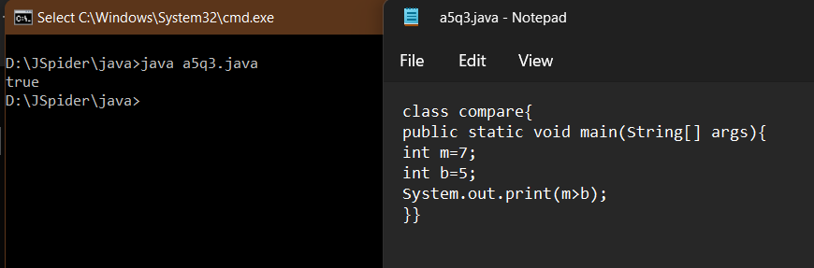

Q4. WAJP to convert meter into centimeter

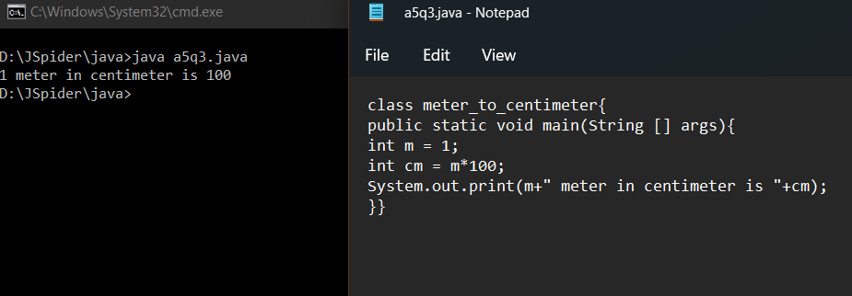

Q5. WAJP to convert meter square into centimeter square

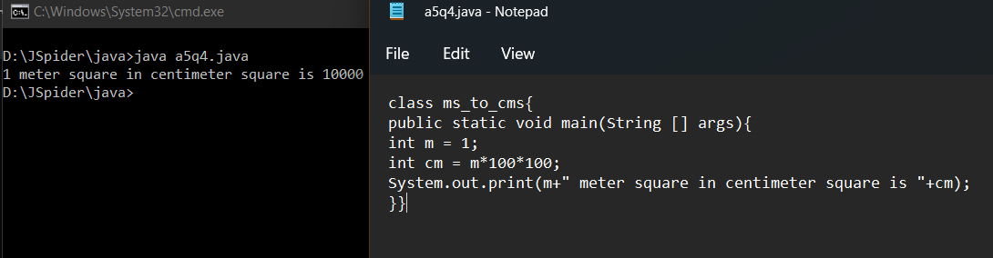

Q6. WAJP to convert mb into kb

